Group 5 Conclusion Document

Preface: We were not sure what to include for the conclusion document.

# Overview

For the deep dive project, we choose to analyze the “Chicago Crime Dataset” with the primary objective of being able to predict future types of crime. As a secondary goal, we identify that if we are able to reasonably predict the types of crime, we can then perform evaluations such as feature importance to evaluate the importance and predictive power of the different features. This feature importance evaluation can be critical as an analysis tool in identifying predictive features, informing, and supporting the need for intervention in different communities or times.

The rest of the conclusion document will briefly discuss motivations, key components in the model architecture, design, and finally some discussion on the findings.

# Motivation

A successful and accurate predictive model has major decision making implications on the part of the police department. With an accurate predictive model, police departments can attempt to anticipate crime types at different locations. With extreme confidence in the model, this might translate to the police allocating resources in particular locations at different times of the day and year. Even without an extremely confident model, this can inform the need to provide different types of intervention such as informative interventions. That is, if the police department is aware that a particular type of crime spikes at a particular time of day or year, they can share important information that can aid in combating this crime. For example, informative posters on how to prevent burglaries, notifications of the dangers of walking home alone at a particular time of day, etc.

# Dataset

By looking at the dataset through a data exploration, trends and commonalities arise to lead us to believe that a deep learning model will be able to learn something. There are a few aspects of the data that we particularly explored: spatial, temporal, and quantitative analysis of the data. Within each of these, patterns and hotspots even visible to the average person arises.

**Spatial.** We begin our discussion by discussing and showing the crime density heat map overlaid the city and suburbs of Chicago.

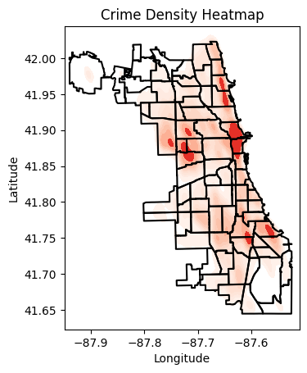

**Temporal.**

**Quantitative.**

Model Architecture and Design:

1. **Temporal Patterns Matter**: The LSTM layer successfully records crime trends across time, demonstrating that crimes might follow predictable patterns according to the time of day or night, such as increased activity on weekends or at night.
2. **Robustness Against Noise**: The model's capacity to generalize is enhanced by dropout and batch normalization, underscoring the significance of managing unpredictability in actual crime data, such as irregularities in location reporting.
3. **Efficiency in Decision-Making**: The Adam optimizer guarantees faster learning, allowing for quicker insights into crime categories. This is essential for prompt actions in urban safety planning.
4. **Feature Transformations are Key**: By embedding category characteristics like "crime type" and normalizing geographical coordinates, the model is able to identify subtle contextual and spatial correlations, including recurring hotspots for particular crimes.
5. **Scalability for Urban Analysis**: The model's modular architecture allows it to be tailored to various cities or bigger datasets, opening the door for more extensive uses in predictive policing and urban safety.